CSE 2320 Notes 16: Shortest Paths

(Last updated 11/8/26 12:11 PM)

CLRS 24.3, 25.2

16.A. Concepts

(Aside: http://dl.acm.org.ezproxy.uta.edu/citation.cfm?doid=2597757.2530531 )

Input:

Directed graph with non-negative edge weights (stored as adj. matrix for Floyd-Warshall)
Dijkstra – source vertex

Output:

Dijkstra – tree that gives a shortest path from source to each vertex
Floyd-Warshall – shortest path between each pair of vertices (“all-pairs”) as matrix

16.B. Dijkstra’s Algorithm – three versions

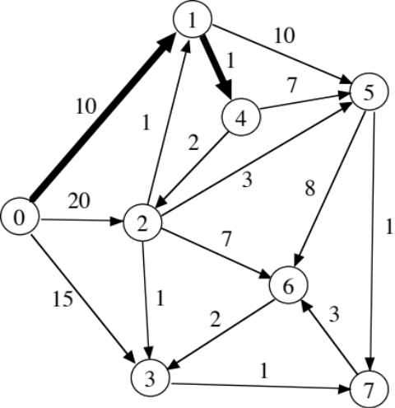

0 1 2 3 4 5 6 7
0(-) ∞ ∞ ∞ ∞ ∞ ∞ ∞
* 10(0) 20(0) 15(0)
* 11(1) 20(1)
13(4) * 18(4)
===========================================================
* 14(2) 16(2) 20(2)
* 15(3)
18(7) *
*
*
Similar to Prim’s MST:

S = vertices whose shortest path is known (initially just the source)

Length of path
Predecessor (vertex) on path (AKA shortest path tree)

T = vertices whose shortest path is not known

Each phase moves a T vertex to S by virtue of that vertex having the shortest path among all T vertices.

Third version may be viewed as being BFS with the FIFO queue replaced by a priority queue.

1. “Memoryless” – Only saves shortest path tree and current partition.
( http://ranger.uta.edu/~weems/NOTES2320/dijkstraMemoryless.c )

Place desired source vertex x ∈ V in S
T = V – {x}
x.distance = 0
x.pred = (-1)
while T ≠ ∅
Find the edge (s, t) over all t ∈ T and all s ∈ S with minimum value for s.distance + weight(s, t)
(i.e. scan adj. list for each s)
t.distance = s.distance + weight(s, t)
t.pred = s
T = T – {t}
S = S ∪ {t}

Since no substantial data structures are used, this takes 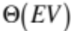 time.

2. Maintains T-table that provides the predecessor vertex in S for each vertex t ∈ T to give the shortest possible path through S to t. ( http://ranger.uta.edu/~weems/NOTES2320/dijkstraTable.c )

Eliminates scanning all S adjacency lists in every phase, but still scans the list of the last vertex moved from T to S.

Place desired source vertex x ∈ V in S
T = V – {x}
x.distance = 0
x.pred = (-1)
for each t ∈ T
Initialize t.distance with weight of (x, t) (or ∞ if non-existent) and t.pred = x
while T ≠ ∅
Scan T entries to find vertex t with minimum value for t.distance
T = T – {t}
S = S ∪ {t}
for each vertex x in adjacency list of t (i.e. (t, x))
if x ∈ T and t.distance + weight(t, x) < x.distance
x.distance = t.distance + weight(t, x)
x.pred = t

Analysis:

Initializing the T-table takes Θ(V).
Scans of T-table entries contribute Θ(V²).
Traversals of adjacency lists contribute Θ(E).
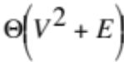 overall worst-case.

3. Replace T-table by a min-heap.
( http://ranger.uta.edu/~weems/NOTES2320/dijkstraHeap.cpp )

The time for updating distances and predecessors increases, but the time for selection of the next vertex to move from T to S improves.

Place desired source vertex x ∈ V in S
T = V – {x}
x.distance = 0
x.pred = (-1)
for each t ∈ T
Initialize T-heap with weight (as the priority) of (x, t) (or ∞ if non-existent) and t.pred = x
minHeapInit(T-heap) // a fixDown at each parent node in heap
while T ≠ ∅
Use heapExtractMin /* fixDown */ to obtain T-heap entry with minimum t.distance
T = T – {t}
S = S ∪ {t}
for each vertex x in adjacency list of t (i.e. (t, x))
if x ∈ T and t.distance + weight(t, x) < x.distance
x.distance = t.distance + weight(t, x)
x.pred = t
minHeapChange(T-heap) // fixUp

Analysis:

Initializing the T-heap takes Θ(V).
Total cost for heapExtractMins is Θ(V log V).
Traversals of adjacency lists and minHeapChanges contribute Θ(E log V).
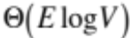 overall worst-case, since E > V.

Which version is the fastest?

Theory Sparse 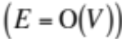 Dense 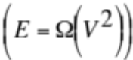

1. 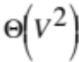 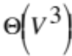
2.
3. 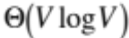 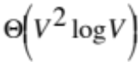

16.C. Floyd-Warshall Algorithm

Based on adjacency matrices. Will examine three versions:

Warshall’s Algorithm – After Θ(V³) preprocessing, processes each path existence query in Θ(1) time.

Warshall’s Algorithm with Successors (or predecessors or transitive vertices) - After Θ(V³) preprocessing, provides a path in response to a path existence query in Ο(V) time (similar to dynamic programming backtrace).

Floyd-Warshall Algorithm (with Successors) - After Θ(V³) preprocessing, provides each shortest path in Ο(V) time.

Warshall’s Algorithm:

for (j=0; j<V; j++)
for (i=0; i<V; i++)
if (A[i][j])
for (k=0; k<V; k++)
if (A[j][k])
A[i][k]=1;
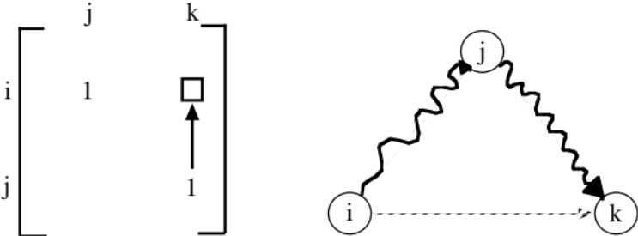

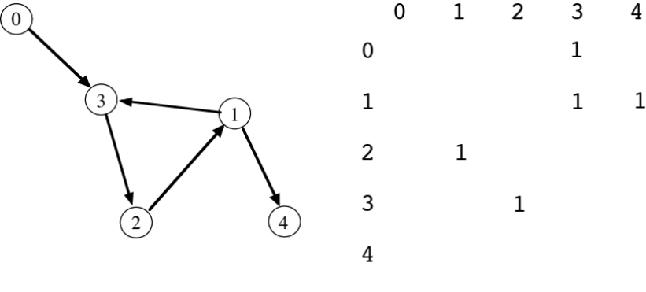

If zero-edge paths are useful for an application (i.e. reflexive, self-loops), the diagonal may be all ones.

Why does it work?

a. Correct in use of transitivity.

b. Is it complete?

When Paths That Can Be Detected

Before j=0 x → y

After j=0 x → 0 → y

After j=1 x → 1 → y
x → 0 → 1 → y
x → 1 → 0 → y

After j=2 x → 2 → y
x → 0 → 2 → y
x → 1 → 2 → y
x → 2 → 0 → y
x → 2 → 1 → y
x → 0 → 1 → 2 → y
x → 0 → 2 → 1 → y
x → 1 → 0 → 2 → y
x → 1 → 2 → 0 → y
x → 2 → 0 → 1 → y
x → 2 → 1 → 0 → y
.
.
.

After j=p x → Permutation of subset of 0 … p → y

After j=V-1 ALL PATHS

Math. Induction:

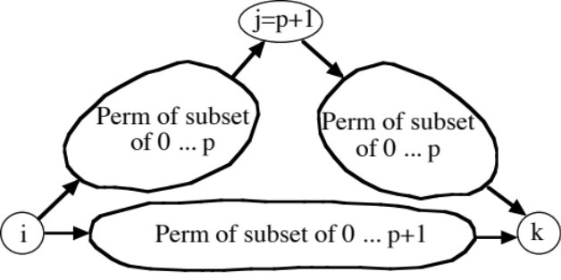
Warshall’s Algorithm with Successors

Successor Matrix

Buc-ee’s directions:
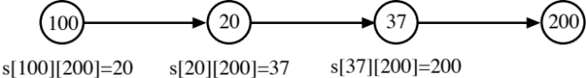

Initialize:
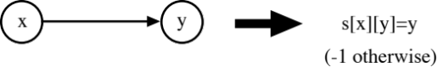

Warshall Matrix Update:

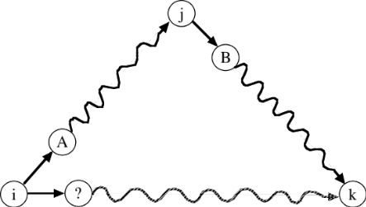

succ[i][j] = A succ[j][k] = B succ[i][k] = ?

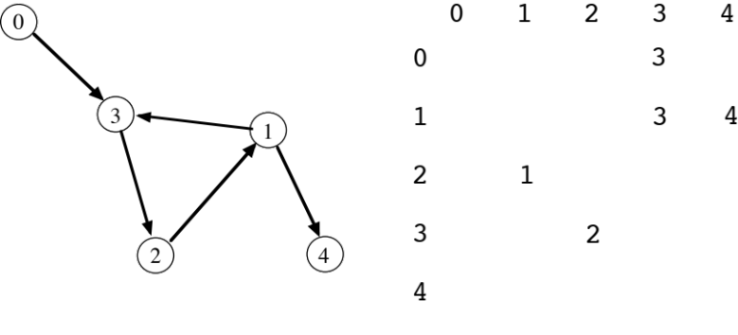

for (j=0; j<V; j++)
for (i=0; i<V; i++)
if (s[i][j] != (-1))
for (k=0; k<V; k++)
if (succ[i][k]==(-1) && succ[j][k]!=(-1))
succ[i][k] = succ[i][j];

Suppose code in box is removed for this graph:

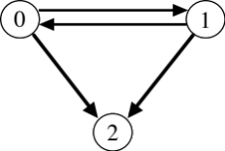
Complete Example ( http://ranger.uta.edu/~weems/NOTES2320/warshall.c ) saving paths using successors:

0 1 2 3 4
0 -1 -1 -1 3 -1
1 -1 -1 -1 3 4
2 -1 1 -1 -1 -1
3 -1 -1 2 -1 -1
4 -1 -1 -1 -1 -1
------------------------
0 1 2 3 4
0 -1 -1 -1 3 -1
1 -1 -1 -1 3 4
2 -1 1 -1 -1 -1
3 -1 -1 2 -1 -1
4 -1 -1 -1 -1 -1
------------------------
0 1 2 3 4
0 -1 -1 -1 3 -1
1 -1 -1 -1 3 4
2 -1 1 -1 1 1
3 -1 -1 2 -1 -1
4 -1 -1 -1 -1 -1
------------------------
0 1 2 3 4
0 -1 -1 -1 3 -1
1 -1 -1 -1 3 4
2 -1 1 -1 1 1
3 -1 2 2 2 2
4 -1 -1 -1 -1 -1
------------------------
0 1 2 3 4
0 -1 3 3 3 3
1 -1 3 3 3 4
2 -1 1 1 1 1
3 -1 2 2 2 2
4 -1 -1 -1 -1 -1
------------------------
0 1 2 3 4
0 -1 3 3 3 3
1 -1 3 3 3 4
2 -1 1 1 1 1
3 -1 2 2 2 2
4 -1 -1 -1 -1 -1
------------------------

Other ways to save path information:

Predecessors (warshallPred.c) Transitive/Intermediate/Column (warshallCol.c)

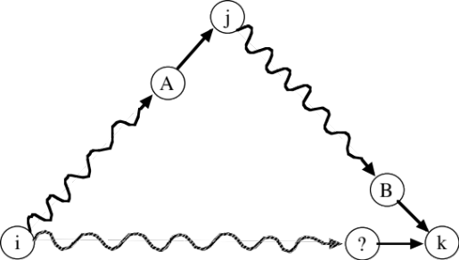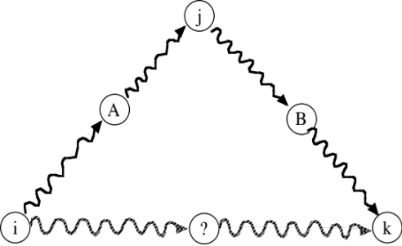

for (j=0;j<n;j++)
for (i=0;i<n;i++)
if (pred[i][j]!=(-1))
for (k=0;k<n;k++)
if (pred[i][k]==(-1) && pred[j][k]!=(-1))
pred[i][k]=pred[j][k];

Floyd-Warshall Algorithm with Successors ( http://ranger.uta.edu/~weems/NOTES2320/floydWarshall.c )

After j = p has been processed, the shortest path from each x to each y that uses only vertices in 0 . . . p as intermediate vertices is recorded in matrix.

for (j=0;j<n;j++)
{
for (i=0;i<n;i++)
if (dist[i][j]<oo)
for (k=0;k<n;k++)
if (dist[j][k]<oo)
{
newDist=dist[i][j]+dist[j][k];
if (newDist<dist[i][k])
{
dist[i][k]=newDist;
succ[i][k]=succ[i][j];
}
}
}

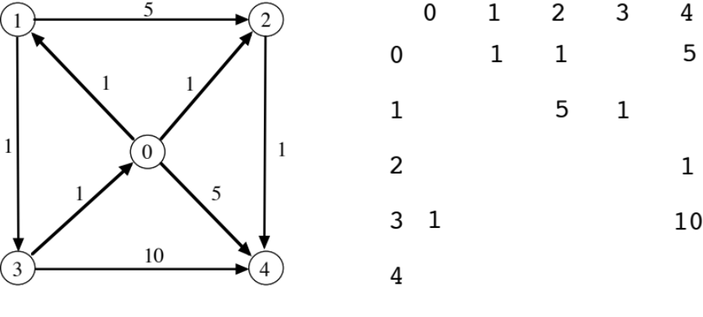

0 1 2 3 4
0 oo 1 1 1 2 oo 5 4

1 oo oo 5 2 1 3 oo

2 oo oo oo oo 1 4

3 1 0 oo oo oo 10 4

4 oo oo oo oo oo

----------------------------------
0 1 2 3 4
0 oo 1 1 1 2 oo 5 4

1 oo oo 5 2 1 3 oo

2 oo oo oo oo 1 4

3 1 0 2 0 2 0 oo 6 0

4 oo oo oo oo oo

----------------------------------
0 1 2 3 4
0 oo 1 1 1 2 2 1 5 4

1 oo oo 5 2 1 3 oo

2 oo oo oo oo 1 4

3 1 0 2 0 2 0 3 0 6 0

4 oo oo oo oo oo

----------------------------------
0 1 2 3 4
0 oo 1 1 1 2 2 1 2 2

1 oo oo 5 2 1 3 6 2

2 oo oo oo oo 1 4

3 1 0 2 0 2 0 3 0 3 0

4 oo oo oo oo oo

----------------------------------
0 1 2 3 4
0 3 1 1 1 1 2 2 1 2 2

1 2 3 3 3 3 3 1 3 4 3

2 oo oo oo oo 1 4

3 1 0 2 0 2 0 3 0 3 0

4 oo oo oo oo oo

----------------------------------
0 1 2 3 4
0 3 1 1 1 1 2 2 1 2 2

1 2 3 3 3 3 3 1 3 4 3

2 oo oo oo oo 1 4

3 1 0 2 0 2 0 3 0 3 0

4 oo oo oo oo oo

----------------------------------

Note: In this example, zero-edge paths are not considered.

